AMANA TRUST DIAGNOSTICS
No 15, Tudun Wada C, Nasarawa LGA, Kano State.
Phone; +2348164093504, +2348033390574
Email; amanatrust2022@gmail.com

11/3/2025 1:58:04 PM

NAME: HAJARA ABDULLAHI | Age: 37y | Sex: F | Ref No:00010
Clinical Details: USG Pelvic |  |  |  | US:10

REAL TIME PELVIC ULTRASONOGRAPHY EXAM: REVEALED:

URINARY BLADDER: Distended with urine with normal mucosal thickness. No gross masses or stone seen.

UTERUS: Anteverted and empty with no evidence of gestation seen, it measured about 48 mm in its AP diameter. No visible pathology is seen.

CUL-DE-SAC: There is mild fluid in posterior cul-de-sac.

IMPRESSION: Normal Pelvic Scan, ?DUB.
Hormonal profile is advised for further evaluation.

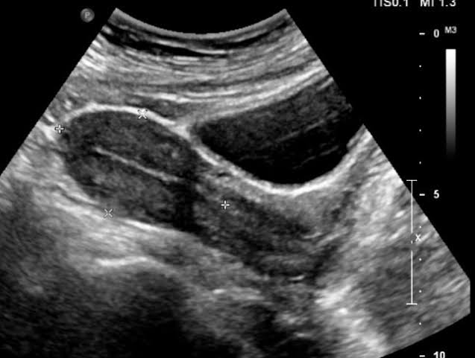

Ultrasound specialist

